1) Title of the project- ContactRed using Android Forensics.

**Project Proposal:-**

Mobile Forensics is the process of analysing and accessing the data from the Mobile devices using forensic tools and different memory acquisition methods so that the Passwords or Passcodes of the device are cracked and able get to the /data/data/ repositories. The Project “Contact Red” is a Red team activity.  
The proposals or ideas of the Project are as follows:  
First to crack the passcode or a way to get into a mobile system. Next getting access to the Phone MMS/SMS depository data and update the settings of a contact such that to block a particular contact like Bank Customer care so that User is unable to see the calls or transaction alerts provided by Bank.

Following are the tools to be used for Project implementation:   
ADB,SQLite commands,

Learning from:

First Deliverable:

1. Android Forensics and Security Testing, presentation By Shawn Valle
2. 2022_Book_MobileForensicsTheFileFormat, about F2F system
3. <https://android-doc.github.io/tools/help/adb.html> , about ADB and Adb commands
4. <https://www.youtube.com/watch?v=UmjDMuwIeAI> , ADB setup using Android studio

Outputs:

As part of the First Deliverable:

> Learnt about F2F system and ADB tool, setup

> Accessing the Device in which the ADB commands will be ran

> Documentation

As part of Second Deliverable:

><https://developer.android.com/studio/command-line/sqlite3>

> <https://stackoverflow.com/questions/25927731/android-adb-command-to-get-total-contacts-on-device>

> <https://developer.android.com/reference/android/provider/BlockedNumberContract>

> <https://www.youtube.com/watch?v=a2FFhAUVUCQ&t=405s> –For developing aMobile app

Outputs:

1. Learnt about ADB Sqlite commands
2. Developed a Mobile app
3. Learnt and implemented about

Step and commands to access DB:

1. Data base of Contacts:

**/data/data/com.** **Android.** **providers.** **contacts/databases/contacts**

1. ADB commands to access sqlite db

adb shell content query --uri content://com.android.contacts/contacts | wc -l

adb shell "am start -a android.intent.action.INSERT -t vnd.android.cursor.dir/contact -e name 'Bo Lawson' -e phone 123456789"

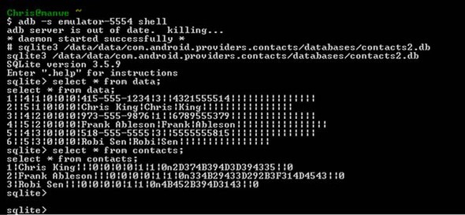

Found that in the latest Android devices, there is a restriction made and throwing permission denied inorder to access the Contacts.db:

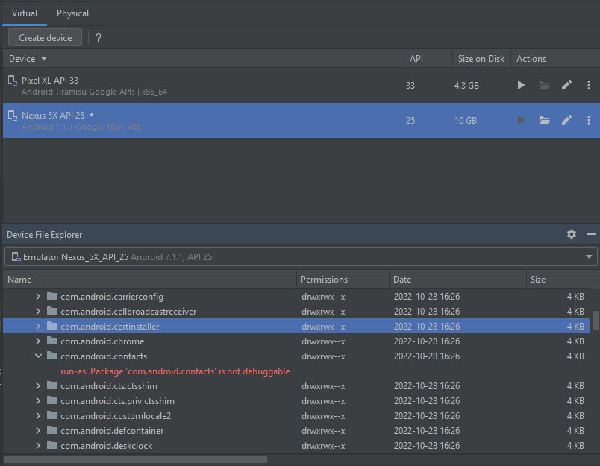

From ADB tool unable to access the Contacts db:

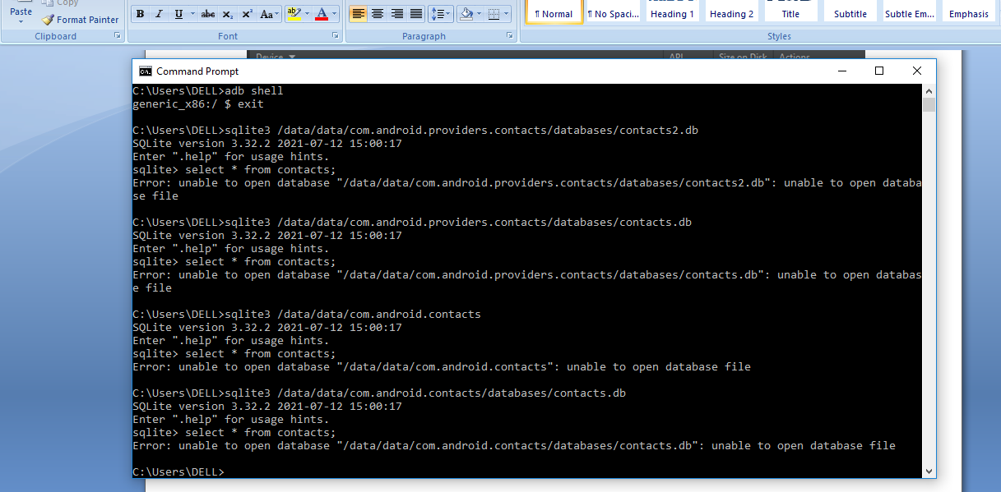

Due to the above restrictions inorder to access the contacts,

Going Next with creating a Mobile app from which we are trying to access, alter and block the targeted contact in the user mobile device:

The Mobile app does:

1. Once installed and run (using adb)
2. User will be shown two input texts and one update button
3. If we know the User contact name like “Ranjith”, we can alter the contact number by giving some random number
4. If user tries to call “Ranjith”, will not be able to reach him

Lets start with the code:

1. Adding the Elements for the app as below:

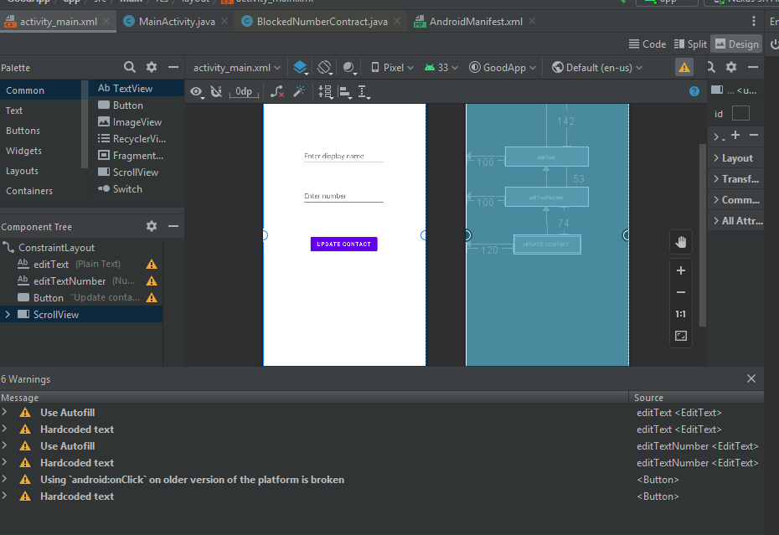

Code:

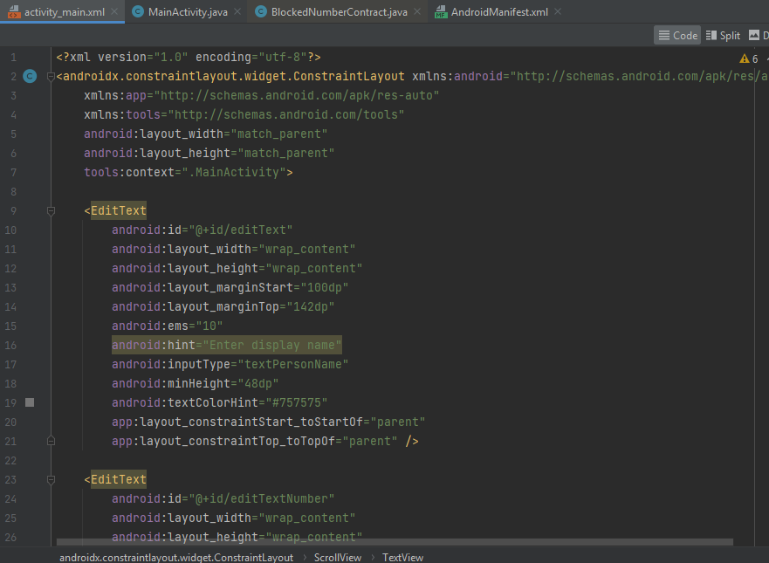

1. Adding Permissions in Android Manifest file

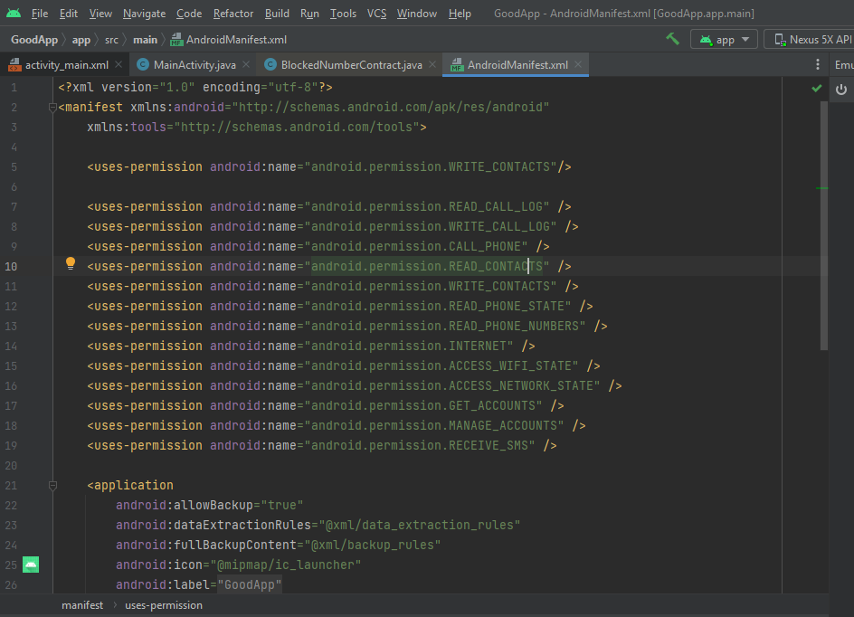

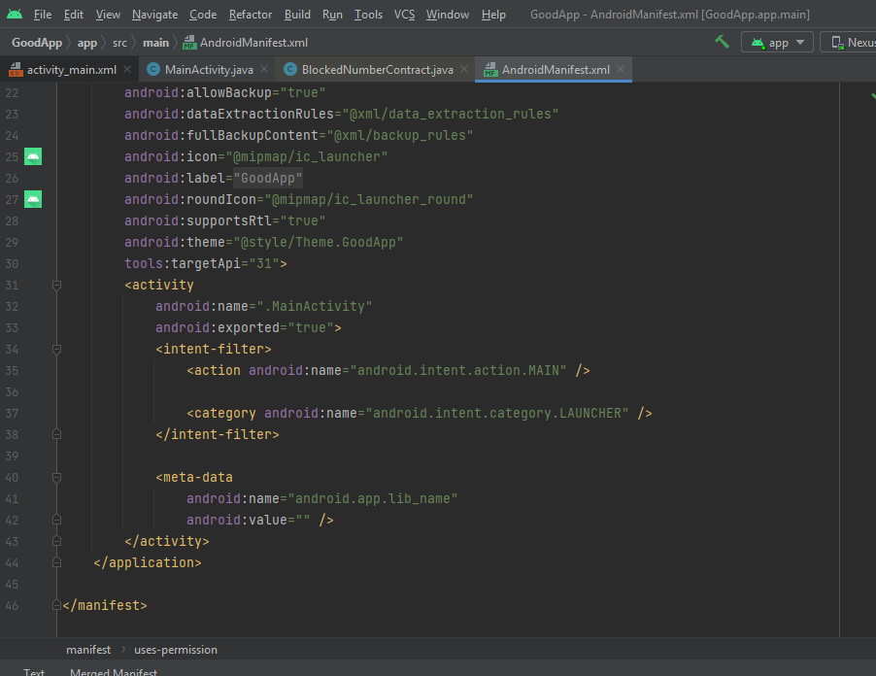

1. MainActivity.java adding code to alter/update the contact of user

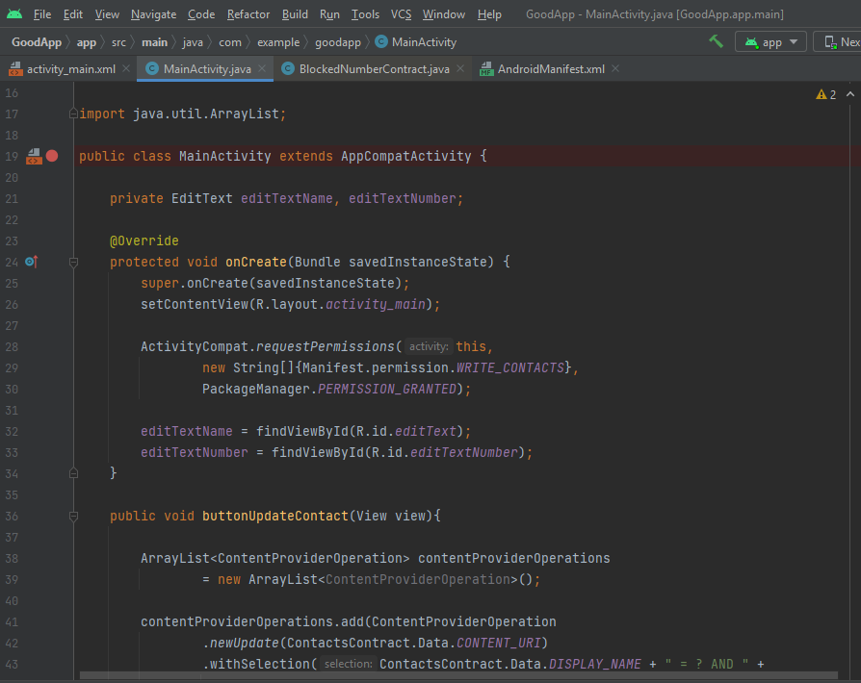

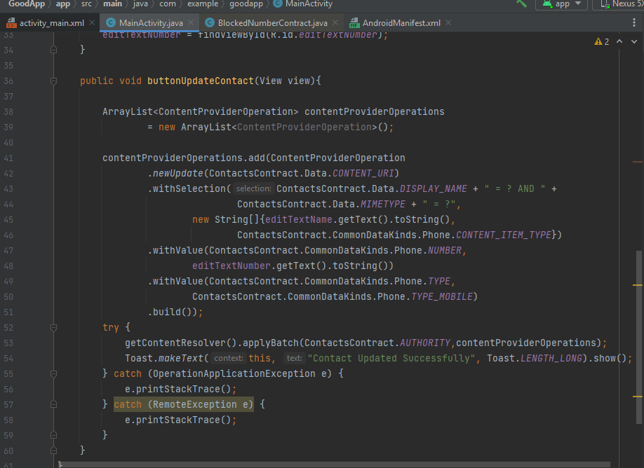

Lets look into the Outputs of the development made above:

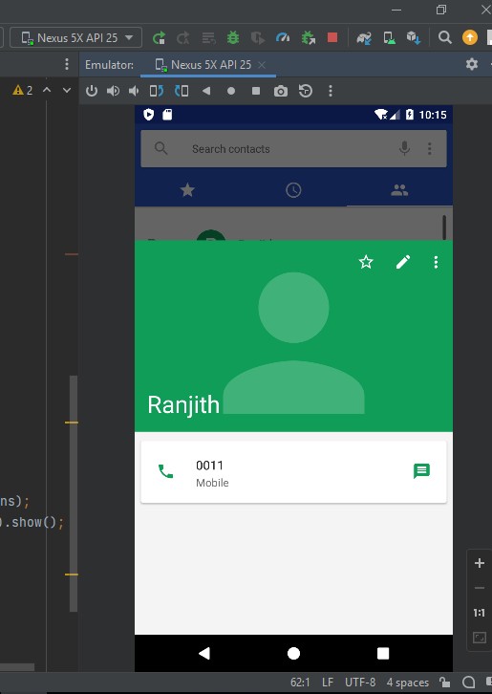

1. Initial Contact number of Ranjith:

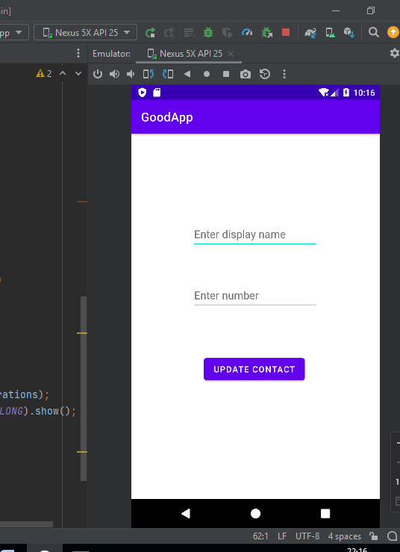

1. After installing and running the App’

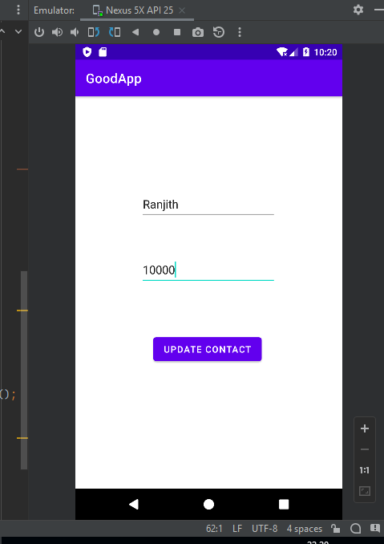

1. Enter the Contact Name and altering number, we want to change and click update

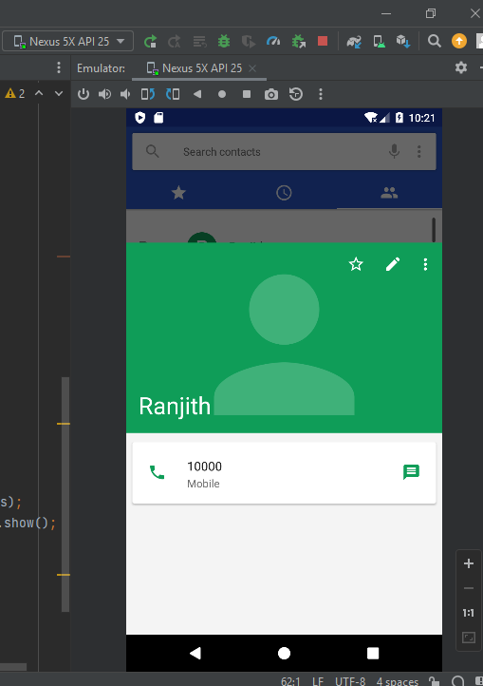

1. We can observe that contact number of Ranjith hasbeen updated

Contributions:

For the development, we have done the Exploring, Knowledge sharing, implementing and documenting processes about the tool, Sqlite and App to access contacts

>Each teammate had spent significant amount of efforts towards the above processes to learn and progress in the project

Next project Deliverables:

* To learn and explore more about the ADB tool and commands to run
* Developing module for blocking the contact
* Working towards the goal of the project to update the contact data